Customer Web Site Overview

Table of Contents
1 Introduction 3
2 Requesting access to the MDV Webpage 4
3 Logging into the MDV Website 5
4 Main Menu 6
5 The Product Menu 7
5.1 Product Inquiry 7
5.2 Product Reports 13
5.3 Cross Division Inquiry 15
6 Deals/Promotions 16
6.1 Vendor Deal Inquiries 16
7 Sales History 18
7.1 MTD Sales Files 18
7.2 Vendor Review 19
7.3 Base Review 20
8 Sales/Purchasing Orders 21
8.1 Vendor Shipping Results 21
8.2 Vendor PO Inquiries 23
8.3 Customer Order Inquiries 24
8.4 Order Inquiry Customer PO 25
8.5 Order Inquiry By Call Number 26
9 Inventory 27
9.1 Aged and At Risk Inventory 27
9.2 New Stock Report 28
9.3 Code Date Inquiry 29
10 Tools 30
10.1 Proof of Delivery Document Retrieval 30
10.2 To Request Proof of Delivery Doc Access 31
10.3 Bulk Reporting 32

Introduction

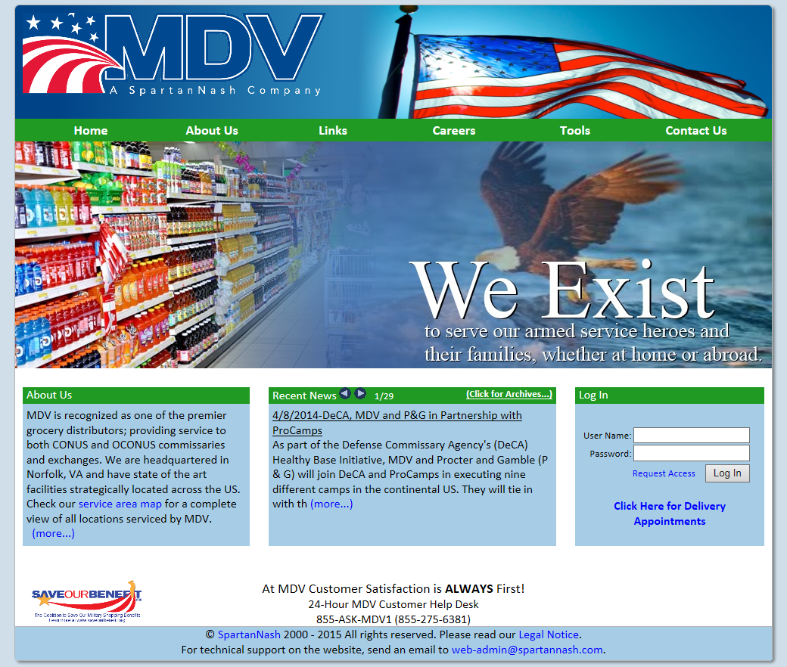
Figure 1 Home Page

MDV Nash Finch has always prided itself in being able to provide the best information to its users in the market. To this end, MDV has dedicated many resources in establishing and maintaining a feature rich Web site. The site contains an array of tools and reports that allow authorized users to retrieve the data they need to accurately assess the performance and status of their products.
The Web site has two main areas: the externally facing pages and the private pages that host the data service tools MDV provides. The externally facing pages are available to all visitors of the www.mdvnf.com internet domain. This set of pages provides basic information to any visitors, as well as established users, pertaining to MDV as a company
The following guide outlines the many features and tools that MDV has made available to established users. Where appropriate, an overview of the functionality is given.

Requesting access to the MDV Webpage

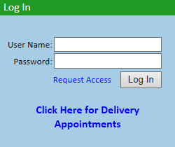
Figure 2.1 Requesting Access

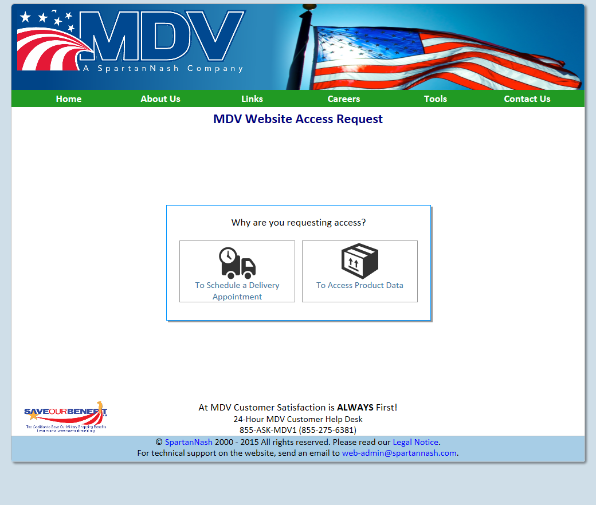
Figure 2.2 Requesting Access

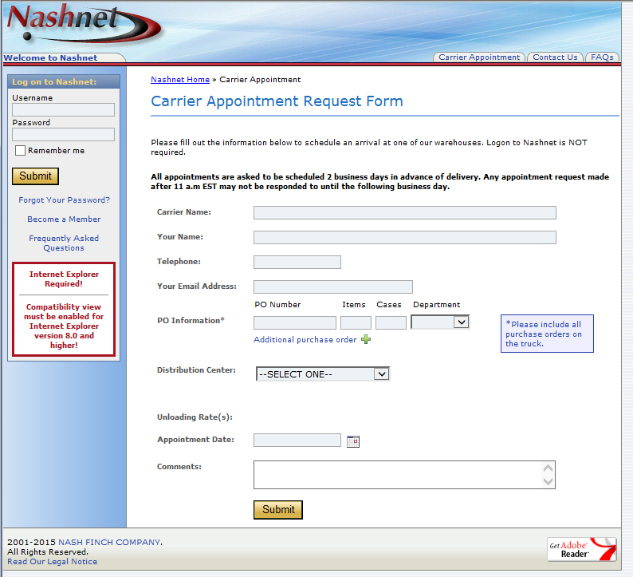
Figure 2.3 Scheduling Appointment
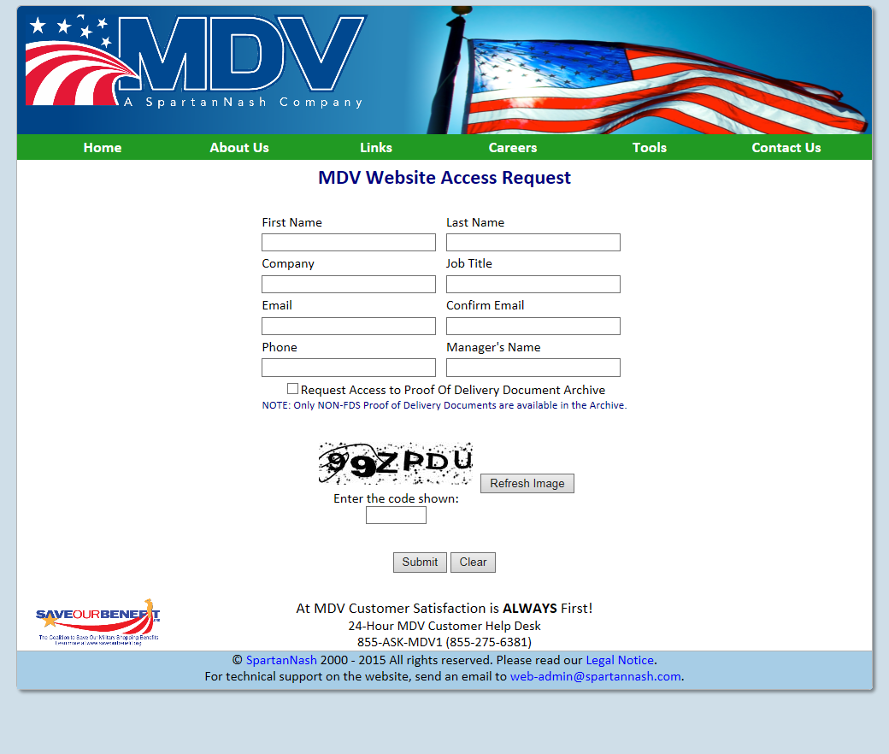
Figure 2.4 Requesting Access

If the visitor to the MDV Web site is new, and does not have any Web site credentials, they can request access to our site online. MDV provides a simple online form for just such a situation. To access this form, the visitor would simply need to click the ‘Request Access’ link just to the left of the ‘Log In’ button in the bottom right corner of the page (Figure 2.1). The next page will ask if the visitor is requesting access to the site to schedule a delivery appointment or to access product data (Figure 2.2). The visitor should click on the appropriate box to proceed. If scheduling a delivery appointment, the visitor will be directed to the Nashnet Carrier Appointment Request Page (Figure 2.3) where the appointment can be requested. No credentials are necessary to schedule the appointment. If the visitor is requesting access to product data they will be directed to the MDV Website Access Request form (Figure 2.4). Once filled out, the form is forwarded to our business managers for review and approval. Upon completion of that process, an email is sent to the new user that contains their newly generated credentials.

Logging into the MDV Website
Figure 3.1 Website Login Screen
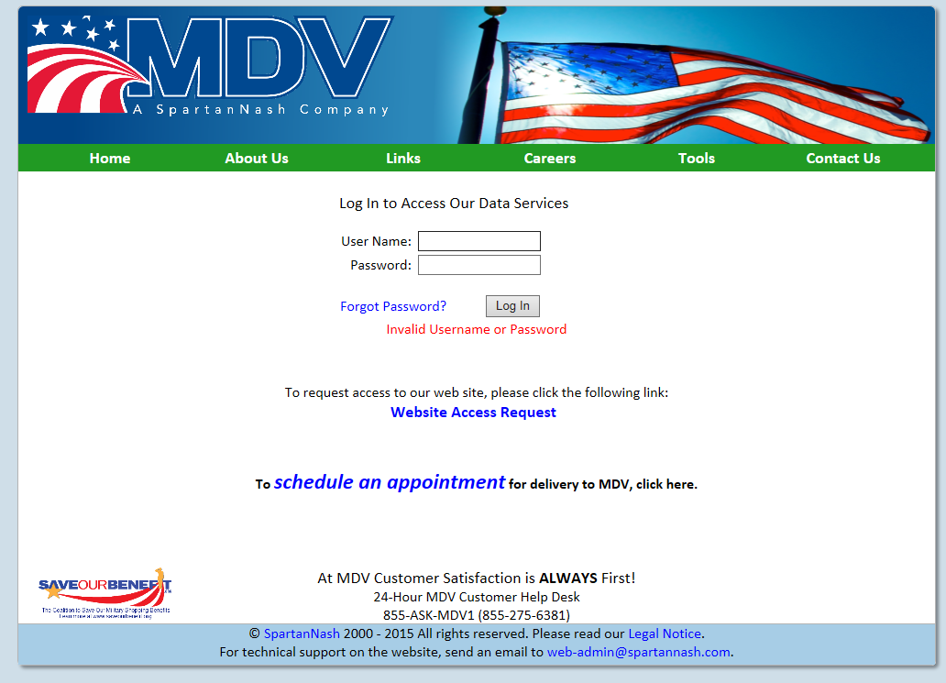
Figure 3.2 Forgot Password

To access the data services features available on the Web site, the user must validate their identity through the log in process. The user utilizes the authentication credentials (i.e. user name and password) for the Log In that are provided to them by MDV. The Log In form is located in the bottom right hand corner of the Home page. Successful authentication will allow the user to enter the protected content and features. If someone with an established account is having difficulty remembering their password and enters an incorrect login, they may request a temporary password via the link under the User Name and Password fields. This will send an email to the address on record for their account, and they will be prompted to change their password upon successful login with this temporary password.

Main Menu

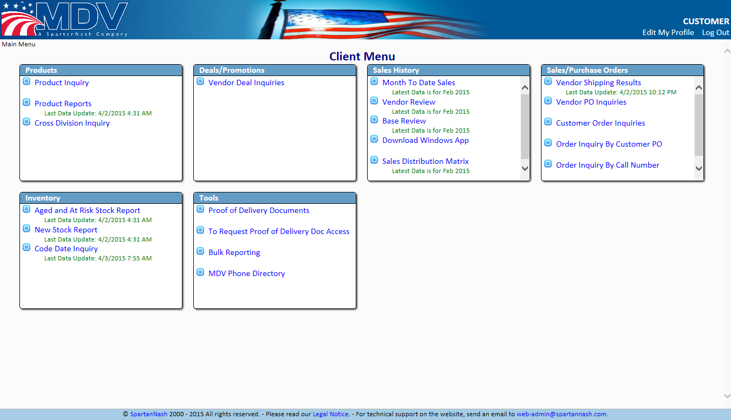
Figure 4 Main Menu

Once the user has been authenticated and granted access to the data services area of the MDV Web site, they are presented with the Client Menu. This menu provides an easy and intuitive way for the user to navigate the array of features, tools, and reports that are offered to them.
The Client Menu is broken up into blocks of similar features or reporting tools, each with a label to briefly inform the user of the tools that will be found in that section. Each option in the block is activated by clicking the hyperlinked feature title. For each item, if the data that is being provided to the user is not retrieved “real-time” then information will be provided below the link in green text informing the user when the information in this option was last updated.

The Product Menu

Product Inquiry
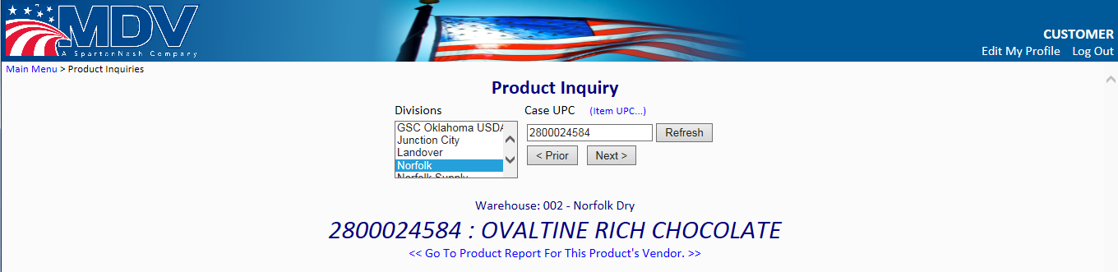
Figure 5 Product Inquiry

The first and most popular feature on the Web site is the Product Inquiry page. This page pulls item specific data from the MDV databases. Every piece of critical information about a product can be found here, broken up into several tabs. In order to retrieve this information the user only needs to select a division from which an item will ship, enter the Case UPC, and then click the ‘Refresh’ button next to the Case UPC field. Additionally, a user can navigate through UPCs via the ‘Prior’ and ‘Next’ buttons under the Case UPC field.
When the request for information has been processed and the data is returned, the page will show the name of the product, the warehouse it was found in, and add a set of tabs on the page just below the query section. Below the item name is a link to navigate to the Product Reports page (section 5.2), and will pre-load the filter set for this item. Clicking on each tab section will show a detailed set of information about the queried product. Each tab will be detailed in the following sub-sections.

Product Inquiry

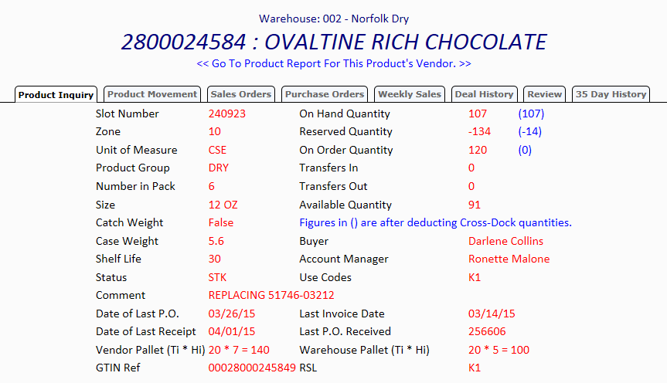
Figure 6 Product Inquiry Tab

The Product Inquire tab shows by default when a product inquiry is performed. Here, users can find basic information regarding to the product such as its location in the warehouse and its quantity.

Product Movement

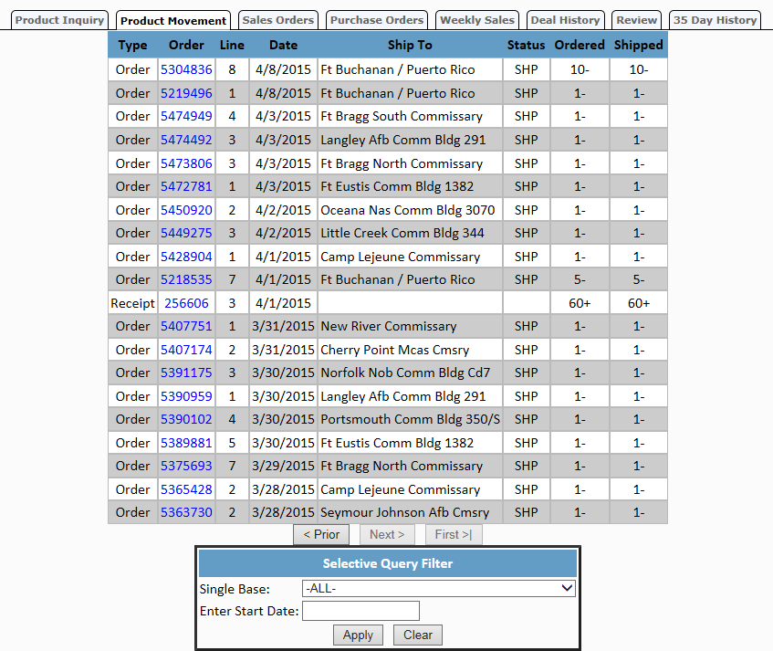
Figure 7 Product Movement Tab

The Product Movement tab shows a history of activity for the queried UPC. Three types of activities are shown on this table: Sales Orders, Receipts, and Adjustments. The results can be filtered to show just a single base and/or starting on a particular date by using the ‘Selective Query Filter’ at the bottom of the page.
The Sales Order or Receipt number will be a hyperlink if there is detailed information for that item available. If the hyperlink is clicked, then a data window will be opened displaying the Sales Order Inquiry Sub-Page for the sales order that was selected, listing all items within that Sales Order. Clicking on the hyperlink for the Case UPC for any product in this menu will return the User to the Products inquiry page for that Case UPC.

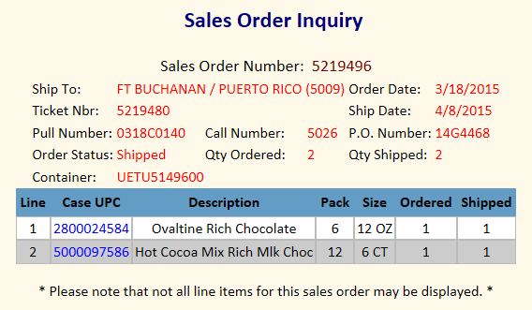
Figure 8 Sales Order Inquiry Sub-Page

Sales Orders

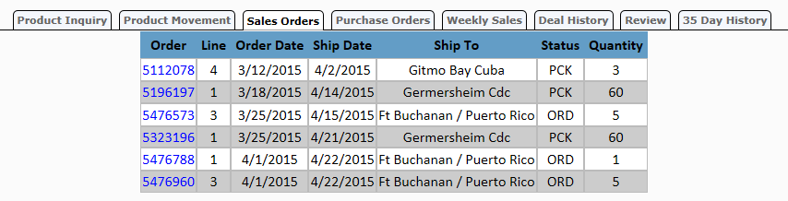
Figure 9 Sales Orders

The Sales Order tab displays Sales Order information for those orders that have not yet been set to a shipped status. Clicking on a hyperlink in the table will spawn a Sales Order Inquiry Sub-Page (the same sub-page as in section 5.1.2) with detail information about the sales order.

Purchase Orders

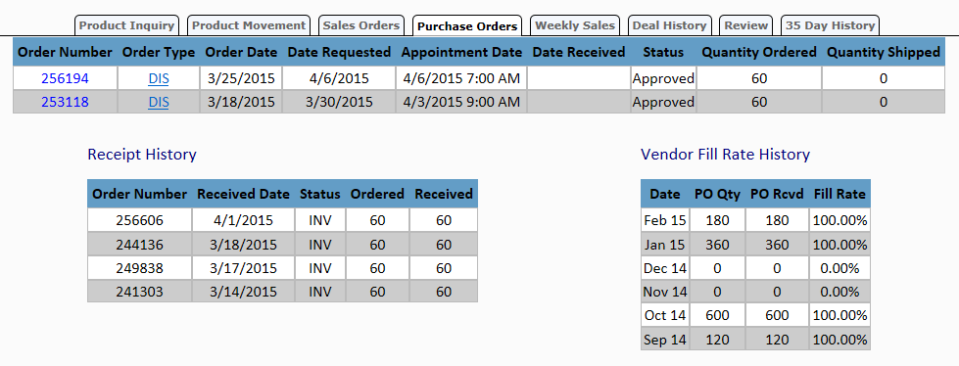
Figure 10 Purchase Orders

This Purchase Orders tab displays general information on the status of MDV purchase orders for the queried product. Clicking on an order number hyperlink in the table will spawn a data window with detail information about the listed purchase order. Clicking on a DIS hyperlink will spawn a Purchase Order Distributions data window. The Purchase order contains the same information as the Sales Order page in section 5.1.2 with the exception that it is for an order instead of a sale.

Weekly Sales

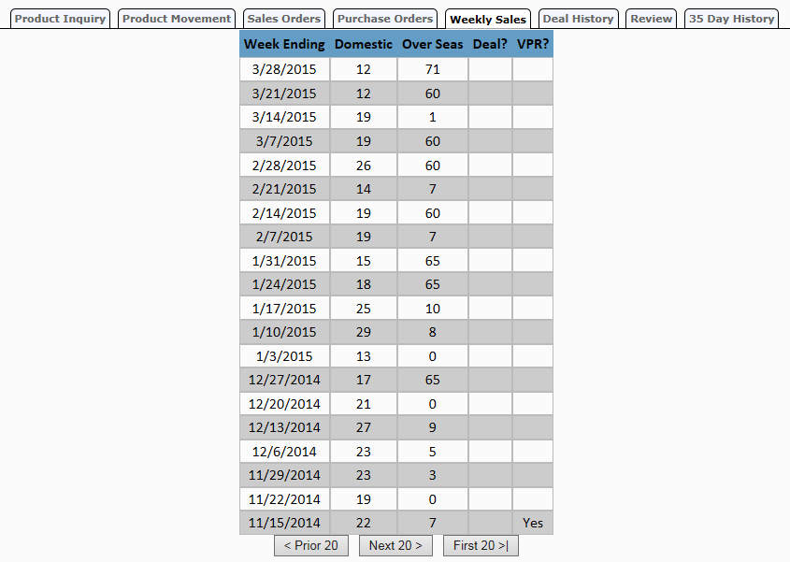
Figure 11 Weekly Sales

The weekly sales tab will display summary information, by week, of the cases sold for the queried product.

Deal History

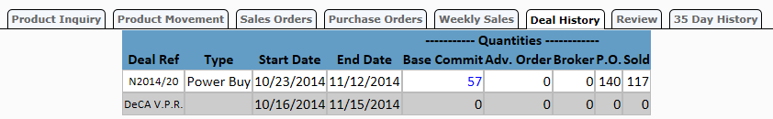
Figure 12 Deal History

The Deal History tab shows a history of the deals that the queried product was a part of. Clicking on a hyperlinked Base Commit or Advance Order quantity will spawn a new data window that will display detailed information about the deal that this product was part of.
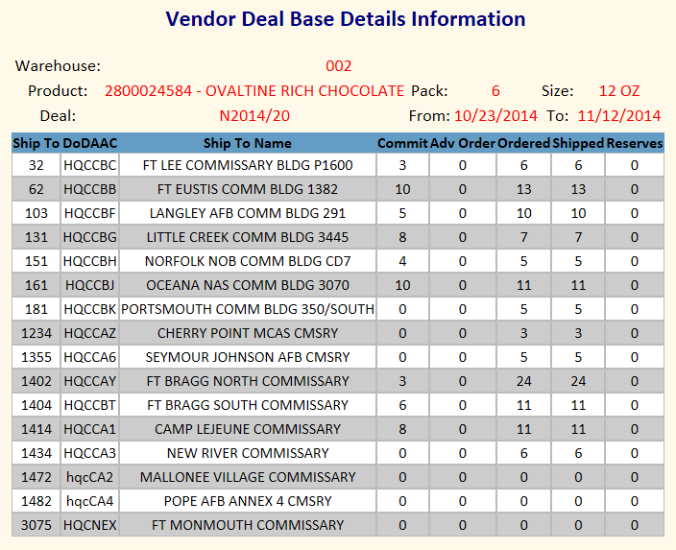
Figure 13 Product Inquiry Vendor Deal Data Window

Review

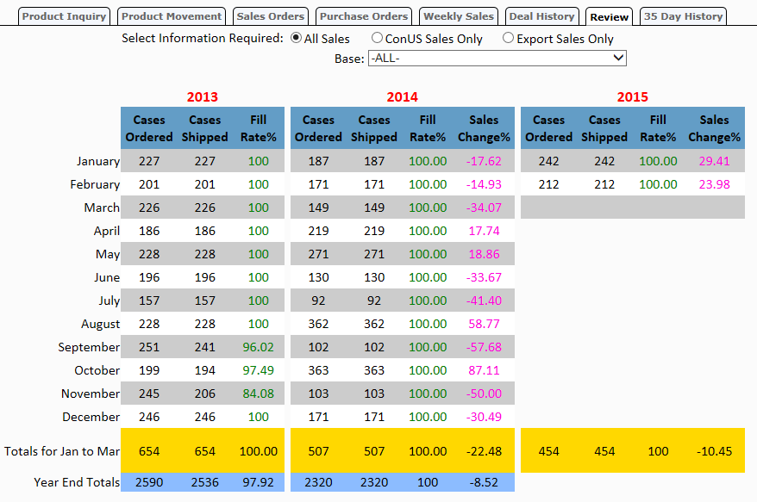
Figure 14 Review

The Review tab displays monthly sales data for the queried product. The table shows a three year history: the current year, the previous year, and the year two years previous. The displayed data can be filtered by area of sales and also by looking at a specific location the item was shipped to.

35 Day History

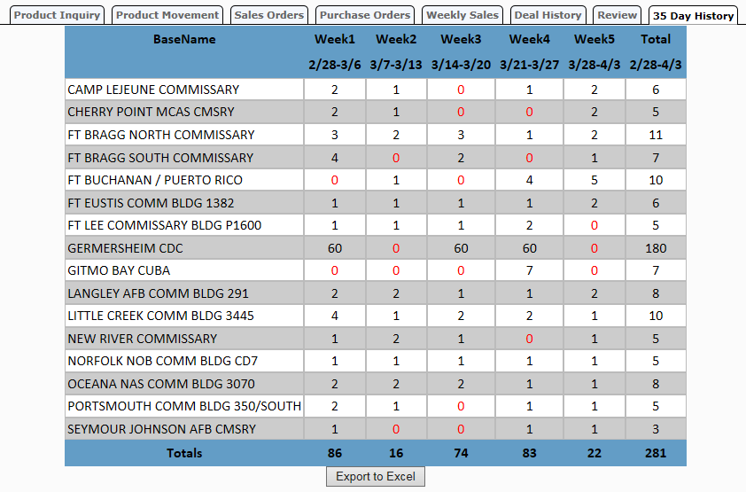
Figure 15 35 Day History

The 35 Day History tab displays weekly sales data for the each of the last 5 weeks by location it was shipped to. The results can be exported to a Microsoft Excel Spreadsheet by clicking the ‘Export to Excel’ button.

Product Reports

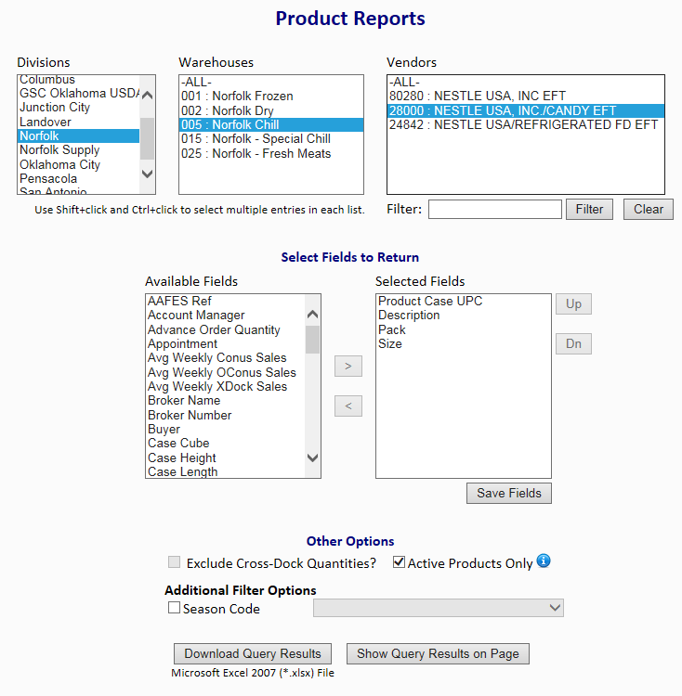
Figure 16 Product Reports

The Product Reports page enables a user to retrieve information about the products they are authorized to view. The page is loosely arranged in three sections. The first uses a left-to-right narrowing feature to select the vendors whose products the user wants to report on. The left-most column lists the available divisions. The center column lists the warehouses that are part of the division that was selected in the first list. The right-most column lists the vendors that are in the warehouse that has been selected in the center column. All three columns support multiple selections and the top entry in all lists is an -ALL- item to allow the querying tool to use all available values from that list.
In the middle section, the user can choose which fields they want to appear on the report when it is generated. Users can select any combination of fields by either clicking a single item, selecting a group of items, or holding the ctrl(control) key and clicking on any items in the list. Once the fields are selected, they can be moved to the Selected Fields list. This is done by clicking the add button: . The entries in the Selected Fields list can be shuffled using the Up and Dn (Down) buttons that are to the right of the list. A field can also be removed from the Selected Fields list by selecting it and clicking the remove button: . This will move it from the Selected Fields list back to the Available Fields list.
The last major section of the Product Reports page is labeled Other Options. This section allows the user to set a few different filtering options before the report query is submitted. The three filtering options are:
- Exclude Cross-Dock Quantities?
If this box is checked, then the quantities listed under these fields will exclude the quantities marked for cross-dock operations.
- Active Products Only
If this box is checked, only those products that are determined to be “active” will be returned in the query results.
- Filter on a single Season
If this box is checked, results of the query will be limited to those products that have the selected season code attached to it.

To execute the query (with the selected fields and filters) the user has a choice of two options. They can select either to see the results in an Excel report or in a separate Web page. By Selecting Download Query Results the user can save the results for their search in an Excel spreadsheet on their local computer. When a user wants to see their results on an in-browser Web page, the results are displayed in a table on a new page. The table can be sorted by a single column by clicking the desired column header. Clicking the hyperlink in the Product Case UPC screen will return the user to the Product Inquiry screen for that product.

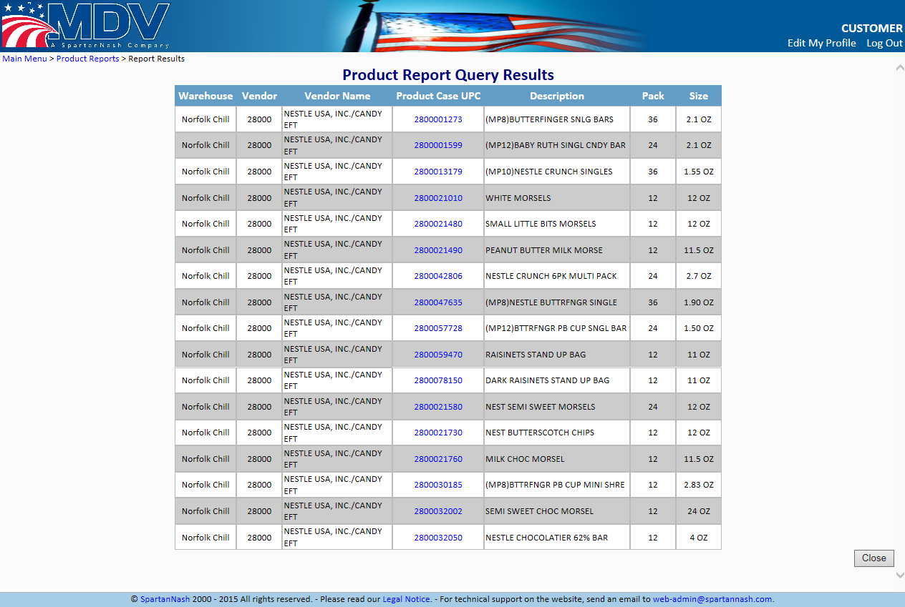

Figure 17 - Product Report Results

Cross Division Inquiry

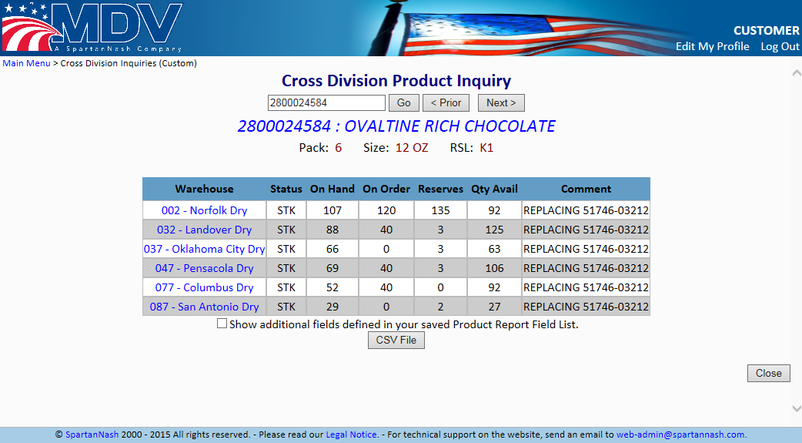

Figure 18 Cross Division Inquiry

Similar to the Product Inquiry screen, the Cross Division Inquiry page allows a user to see information related to a Case UPC, specifically which warehouses a product resides in and its quantity information for each warehouse. The input box is used to input the Case UPC they wish to look up. The results will be displayed as a table below the input controls
If a partial UPC is entered into the box and submitted, the results for the closest matching UPC will be returned. Clicking the ‘< Prior’ or ‘Next >’ buttons will cause the page to look for the next UPC in the database. Clicking on the Warehouse Name will return the user to the Product Inquiry screen for more detailed information on that product. If the user wants to download the results to a file on their computer they can click the ‘CSV File’ button which will save the information to their computer in a Comma Separated Values format (*.csv) which can be read by any text editor program.

Deals/Promotions

Vendor Deal Inquiries

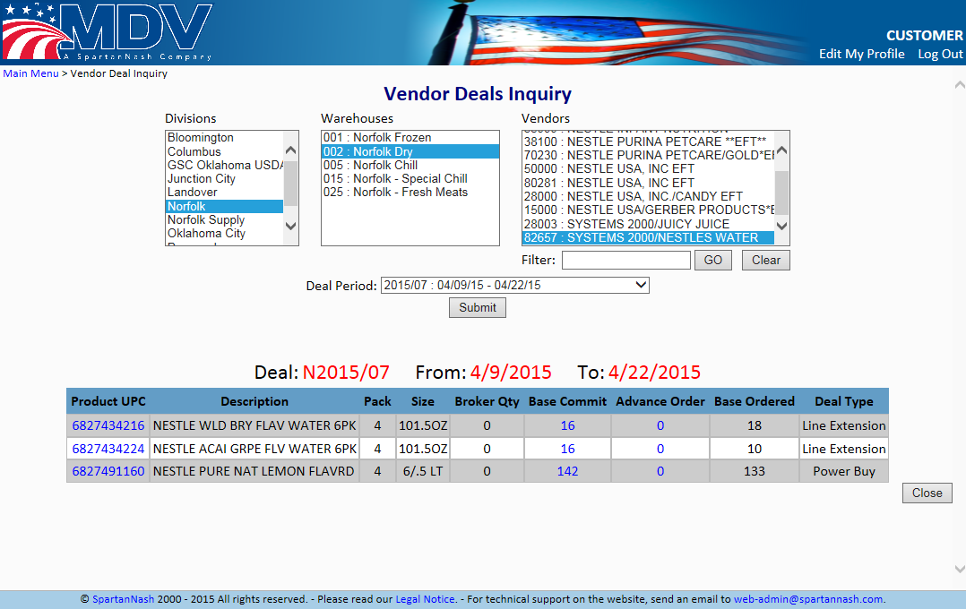
Figure 19 Vendor Deal Inquiries

The Vendor Deal Inquiries page allows the user to view the products that are a part of a chosen deal reference. The initial starting point for this page shows a three column selector of division, warehouse and vendor. Selecting a division populates the warehouse list with the selected division’s warehouses. Selecting the warehouse populates the vendor list with the vendors that have product in the selected warehouse. The user can also choose which deal reference period that they want to query. A drop-down list is located below the three column selector for this purpose.
Once the data is returned, a table is generated showing those products that match the criteria specified earlier. The table has three hyperlinked columns: Product UPC, Base Commit, and Advance Order. The Product UPC hyperlink will return the user to the Product Inquiry for that product. Both the Base Commit and Advance Order hyperlink will open the Vendor Deal Base Details Information sub window.
The Vendor Deals Base Detail Information sub window provides details of what each base ordered for the product selected.

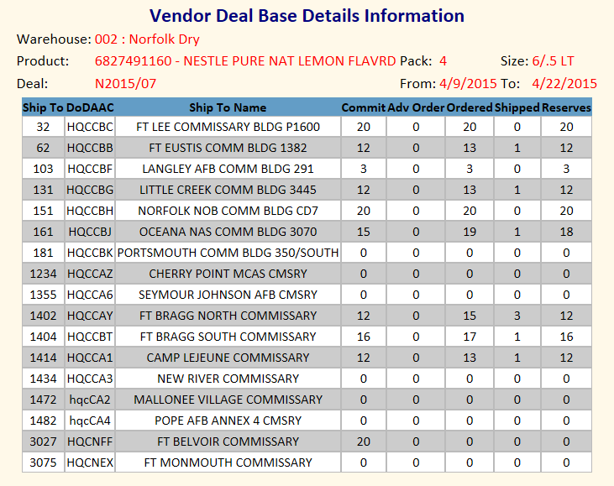

Figure 20 Vendor Deal Base Details Information Data Window

Sales History

Month to Date Sales

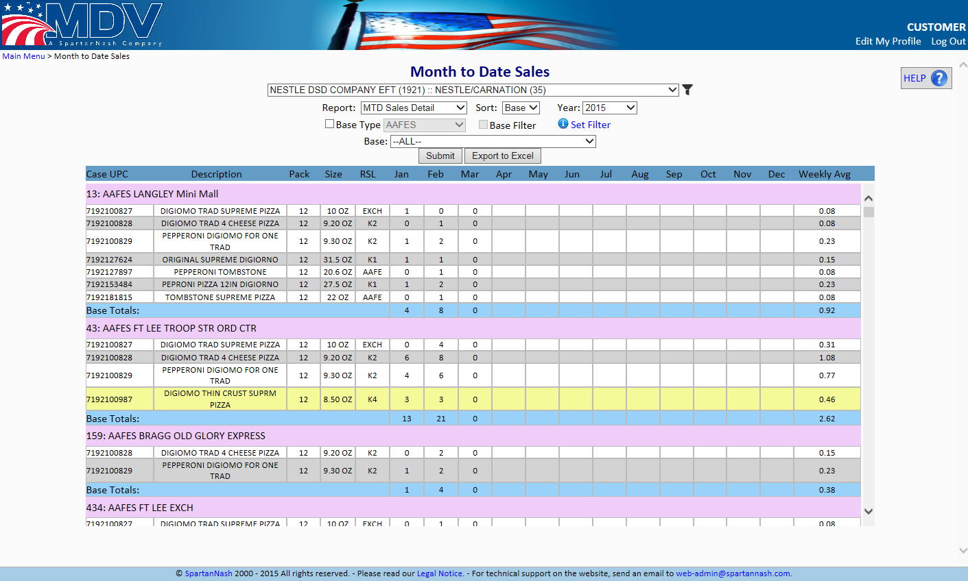

Figure 21.1 MTD Sales Detail

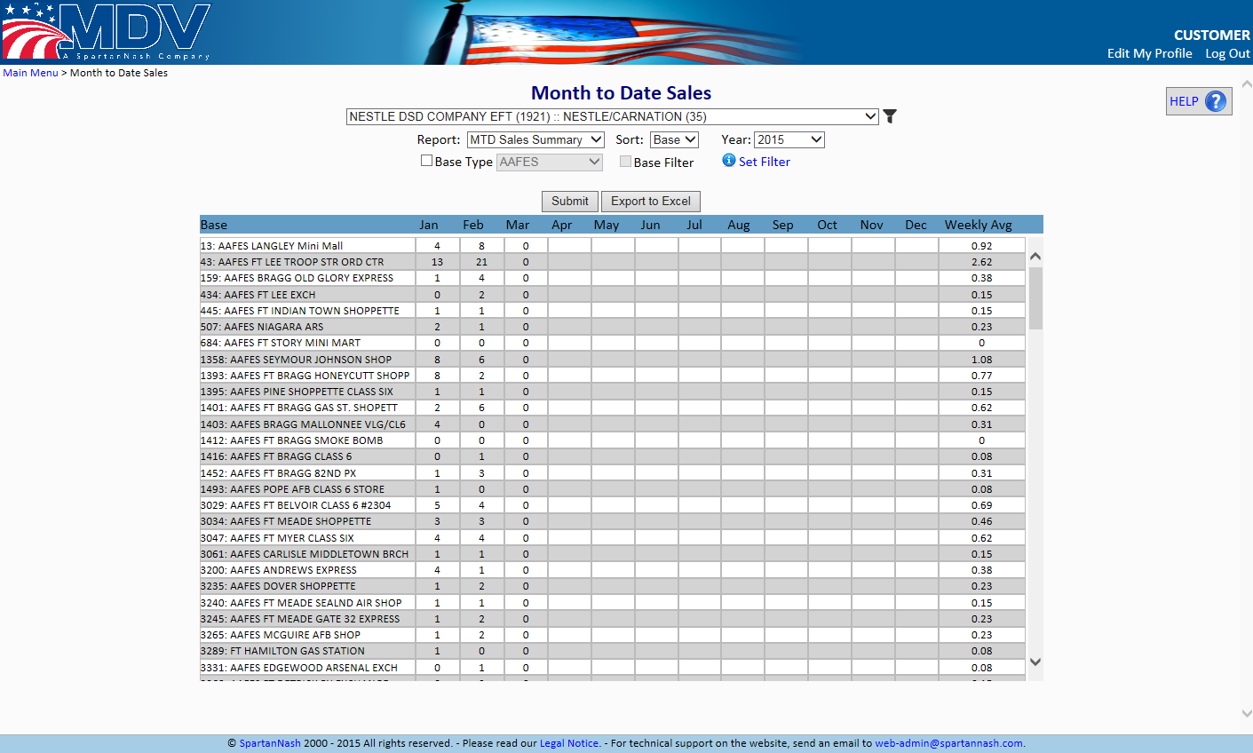
Figure 21.2 MTD Sales Summary

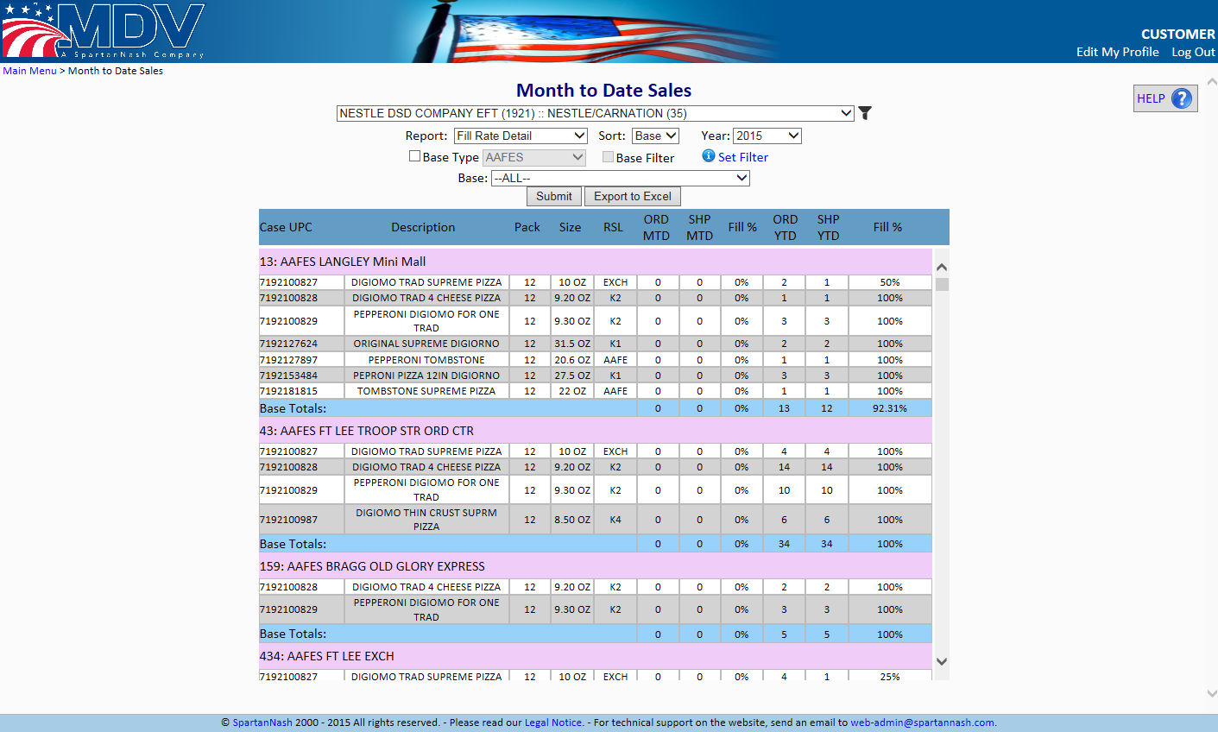
Figure 21.3 Fill Rate Detail

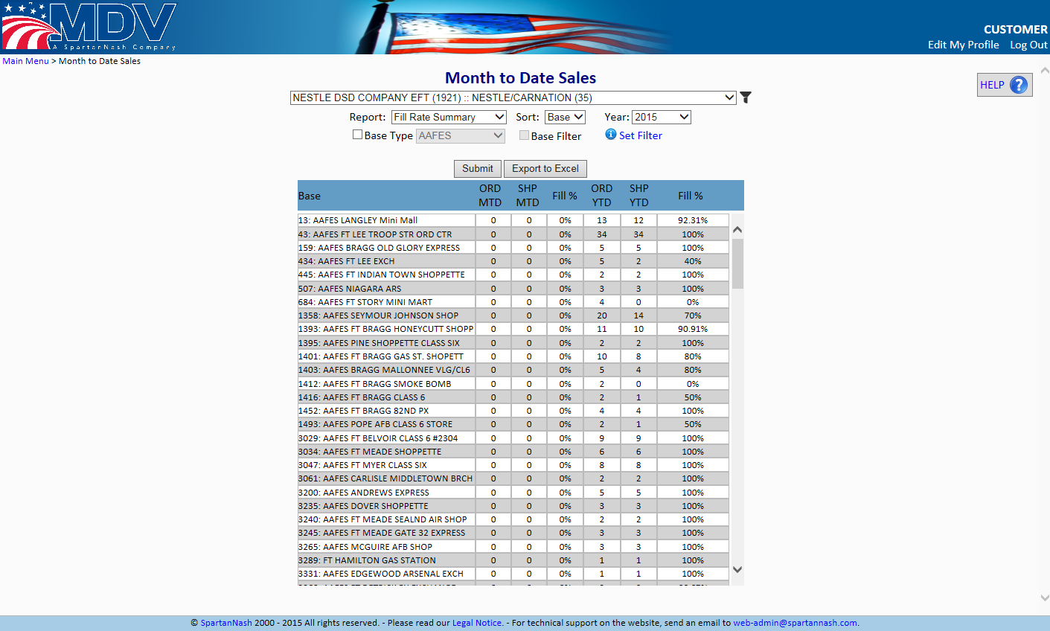
Figure 21.4 Fill Rate Summary

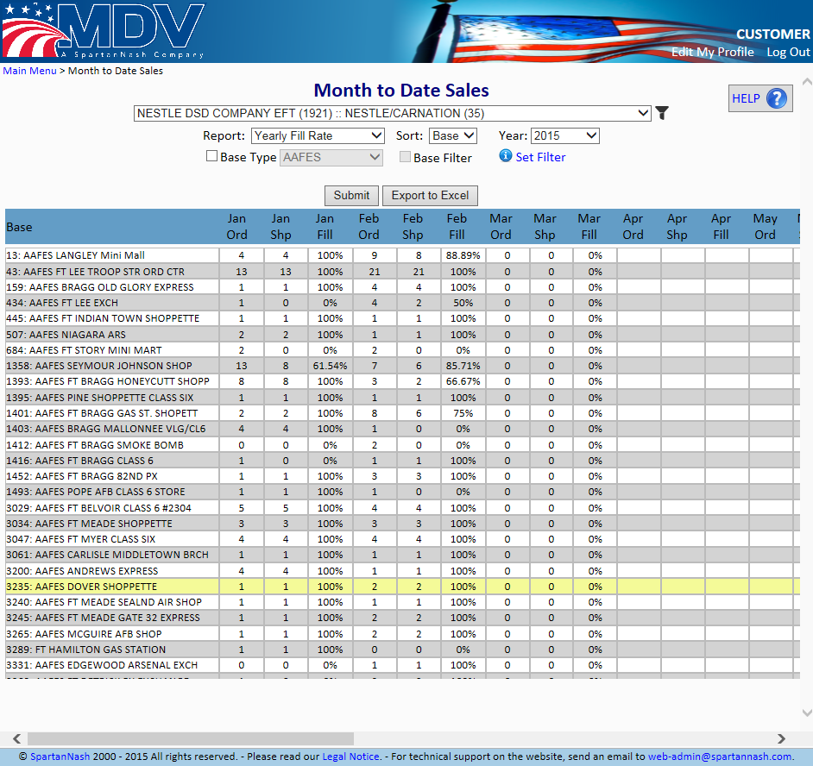
Figure 21.5 Yearly Fill Rate

The Month to Date Sales page allows users to view various Sales and Fill Rate Reports. After the user selects a vendor they can choose the report they want to view from the Report drop-down menu and then choose to sort and filter by UPC, Base, Base Type and the Year they want to display. They can click the ‘Submit’ button to display the results on the screen or click the ‘Export to Excel’ button to download the results into an Excel file on their local computer.

Vendor Review

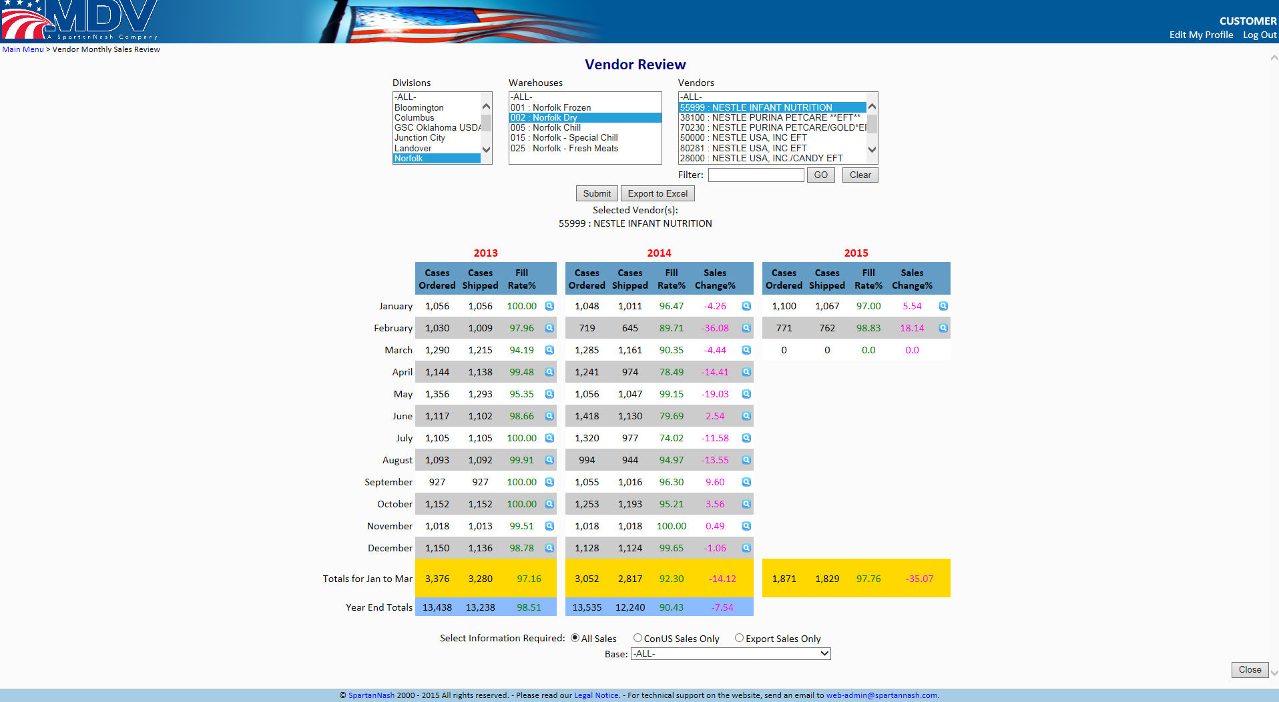

Figure 22 Vendor Review

The Vendor Review page displays a three year history of the performance (in cases ordered vs. cases shipped) of a vendor. The data comes from our monthly roll up of sales data.
The page initially displays the three column selector that is common among many of the Web site’s pages. There is a division column, a warehouse column, and a vendor column. Selecting the division populates the warehouse list. Selecting the warehouse populates the vendor list. It should be noted that only those vendors that have had sales in the last three years and (when applicable) are available to the customer will appear in the vendor list.
Once the data is returned, a data table and several filtering controls will appear on the page. The table shows the three year performance data. The filtering controls will allow the user to change the data shown in the table. The displayed data can be filtered by area of sales and also by looking at specific location the item was shipped to. Clicking on the button will display the detailed results for that particular month.

Base Review

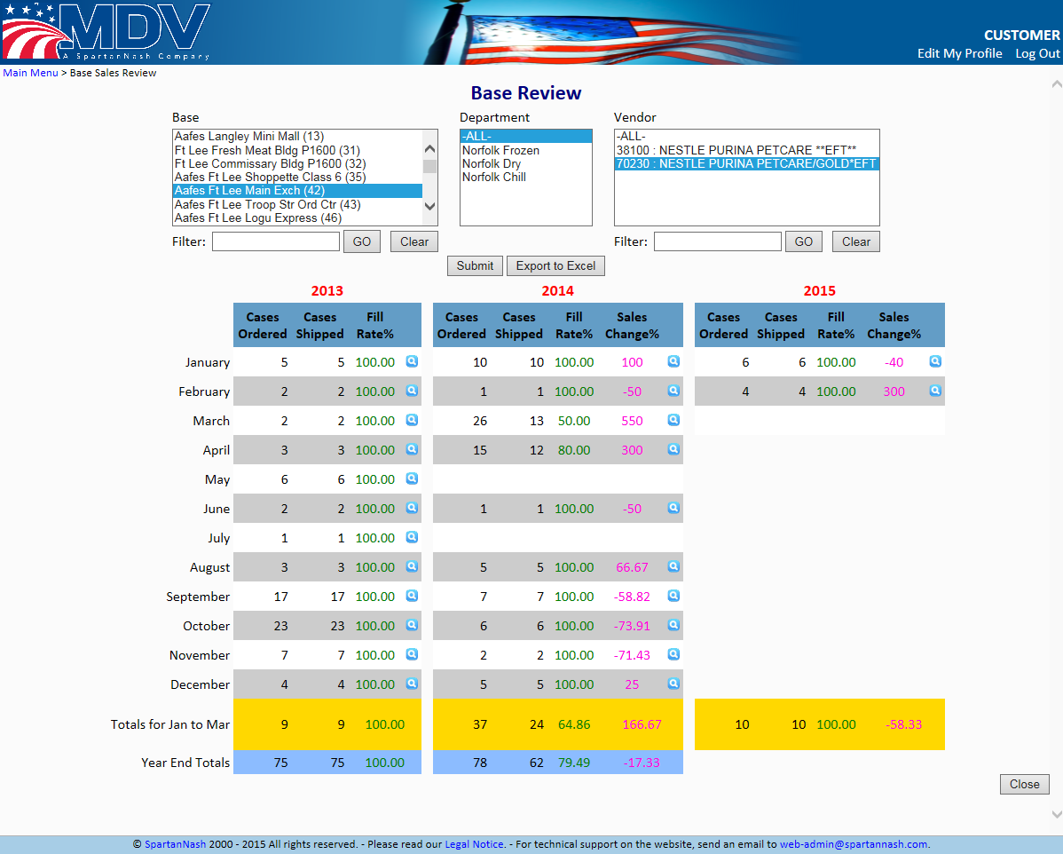

Figure 23 Base Review

The Base Review page allows the user to query the performance of vendors (in cases ordered and cases shipped) at different delivery locations. This data is fed from the monthly roll-up of sales data.
The page initially displays a three column selector that is similar to the one that many of the site’s pages. The first (left-most) column lists all of the Bases that had recorded sales over the last three years. The middle list is for Department. This list will be populated whenever a Base(s) is selected with the departments that have shipped items to the selected Base(s). The final list is the Vendor list. This list is populated when a department is chosen and is filled with the vendors that have had product shipped from the selected department(s) to the selected Base(s). Clicking the button will display information for all products for the current search criteria.

Sales/Purchasing Orders

Vendor Shipping Results

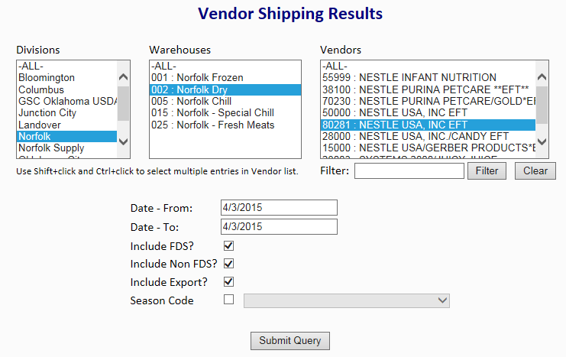
Figure 24.1 Vendor Shipping Results (pg1)

Vendor Shipping Results will display all information for items shipped by a vendor. Similar to many pages within the MDV website, a user can search for all vendors available to them by selecting any combination of Divisions, Warehouses within those Divisions, and any Vendors with products in those Warehouses. The user can then narrow their search down by a specific date (with a maximum of 35 days per search). If the user desires, they can select only vendors that shipped products and fall under FDS, non FDS, Export, or Seasonal Categories.

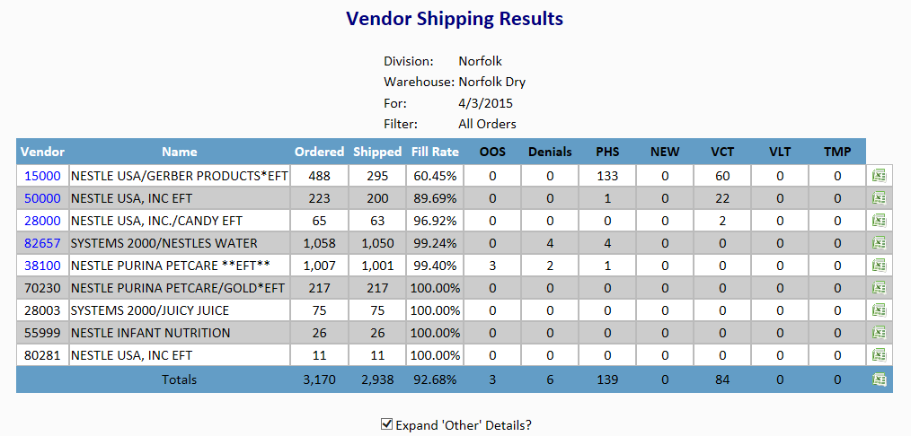
Figure 24.2 Vendor Shipping Results (pg2)

When the Query is submitted, results are returned with information regarding the Vendors that fit the provided filters. For each vendor the quantity of units ordered, units shipped, and the fill rate for that vendor will be displayed along with relevant item statuses. Clicking on the Vendor number will display detailed information regarding the products for that vendor. Alternately, the user can click the Excel icon at the end of each row to save this detail information to their computer as an Excel spreadsheet.

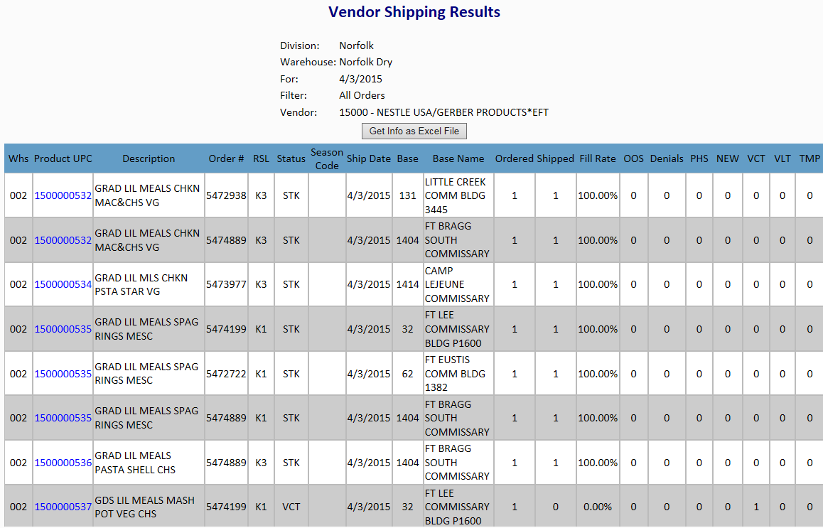
Figure 24.3 Vendor Shipping Results (pg3)

If the user decides to display the results via their web-browser by clicking on the vendor number, the information will be displayed as it would be in the Excel file. The user can still export this information to Excel by clicking the ‘Get Info as Excel File’ button.

Vendor PO Inquiries

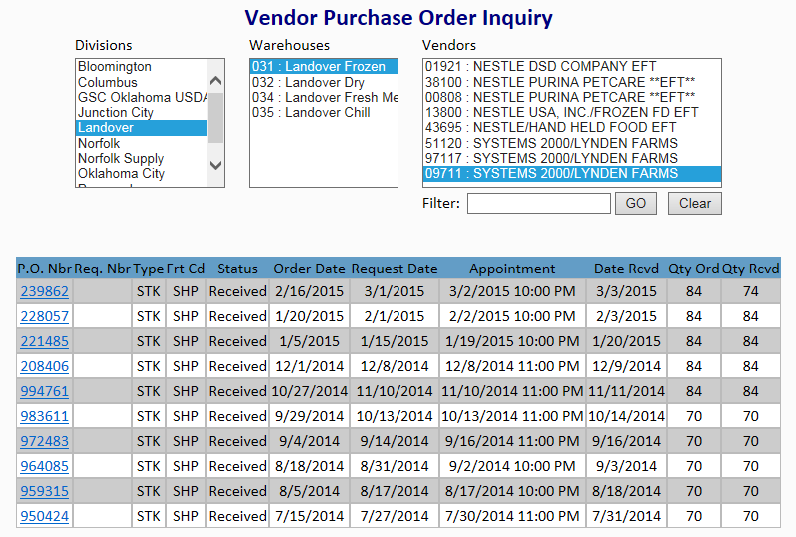

Figure 25 Vendor PO Inquiry Page

The Vendor Purchase Order Inquiries page allows the user to view the list of MDV purchase orders. The initial starting point for this page shows a three column selector of division, warehouse and vendor. Selecting a division populates the warehouse list with the selected division’s warehouses. Selecting the warehouse populates the vendor list with the vendors that have product in the selected warehouse.
Once a vendor is selected in the vendors list, the query is immediately submitted and the data returned. The data returned to the client is a list of purchase order headers. The purchase order number is hyperlinked in the data table. Clicking on the link causes a data window to pop up that contains detailed information about the selected purchase order. The data table shown in the data window has the Case UPC hyperlinked. Clicking on the link will redirect the user to the Product Inquiry listing for that UPC.

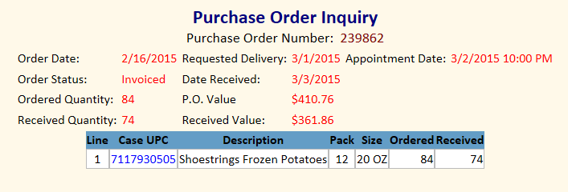

Figure 26 Vendor Purchase Order Inquiry Data Window

Customer Order Inquiries

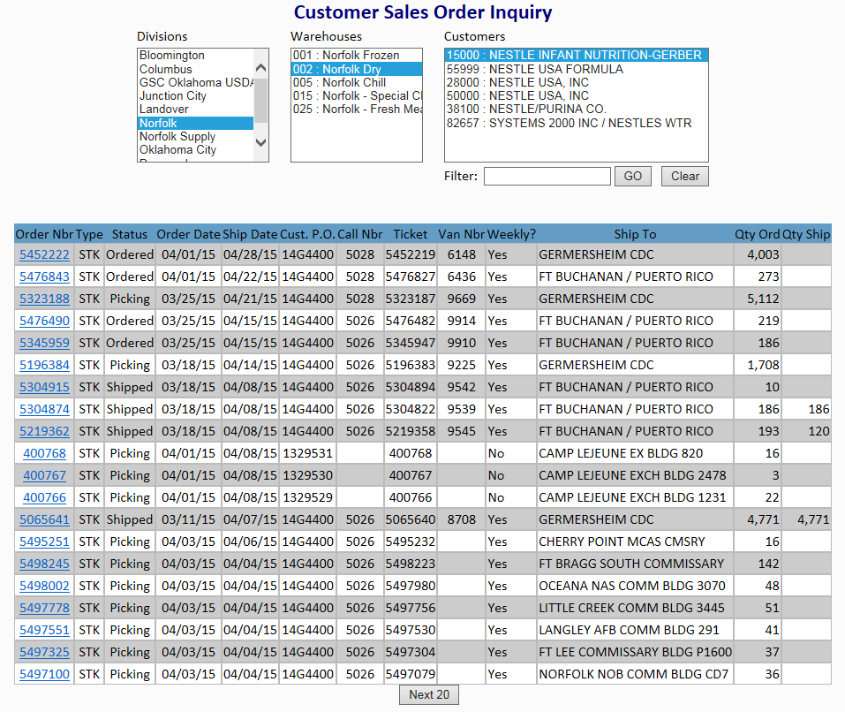
Figure 27 Customer Order Inquiries
The Customer Order Inquiries allows user to view details about sales orders that are in our system. The initial starting point for this page shows a three column selector of division, warehouse and customer. Selecting a division populates the warehouse list with the selected division’s warehouses, or departments, and selecting a warehouse populates the customer list with customers that have product in the selected warehouse. Once a Customer is selected in the Customers list the query is immediately submitted and the data returned that displays information on each of the sales orders that has been issued for that customer.
The first column contains hyperlinked values. These links will open up a data window that displays details about that particular sales order. Header information and individual line information is provided.

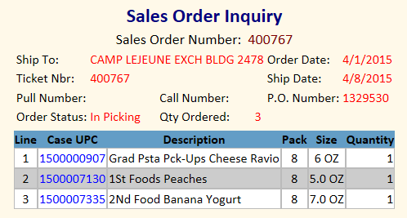

Figure 28 Customer Sales Order Inquiry Data Window

Order Inquiry By Customer PO

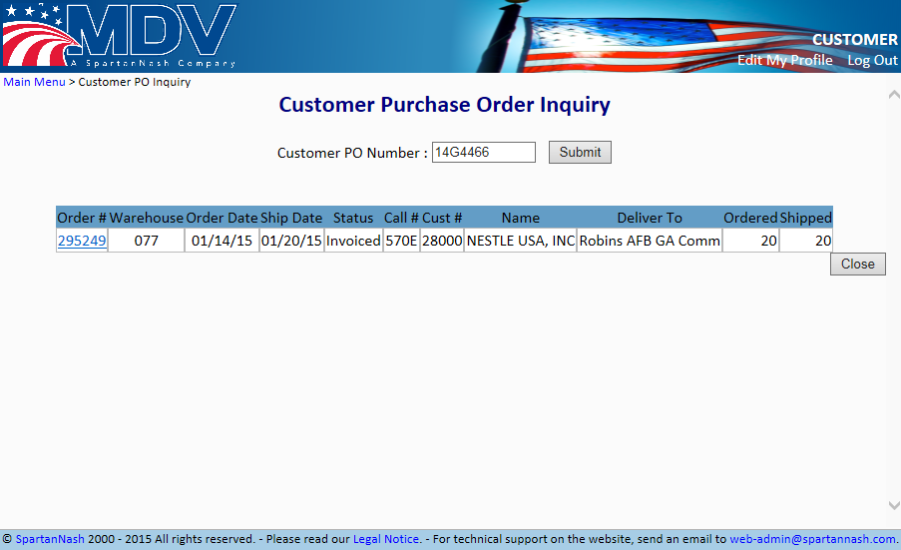
Figure 29 Customer Purchase Order Inquiry

This page allows a user to look a specific purchase order header by Customer PO number. The user would enter their PO number into the input box provided and then click the submit button to initiate the query. When the data is returned the order number is hyperlinked. Clicking on the link will display the Sales Order Inquiry data window associated with that line in the Customer Purchase Order.

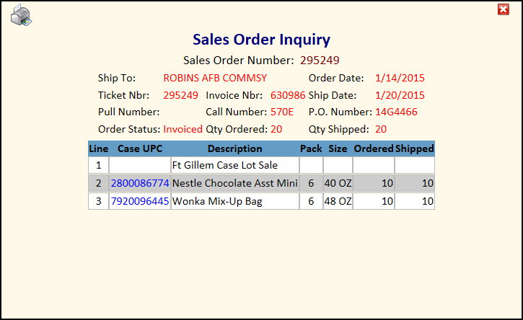
Figure 30 Order Inquiry by Customer PO - Sales Order Inquiry Data Window

Order Inquiry By Call Number

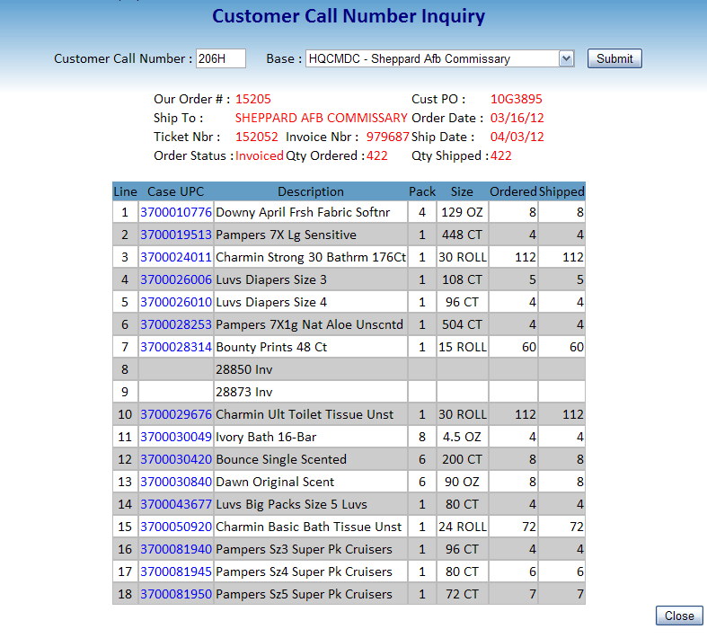
Figure 31 Order Inquiry by Call Number

This page allows the user to query for a sales order by inputting a Call Number and selecting a shipping location. Clicking the submit button will initiate the query. The data that is returned is the actual details of the order ticket for that location.

Inventory

Aged and At Risk Inventory

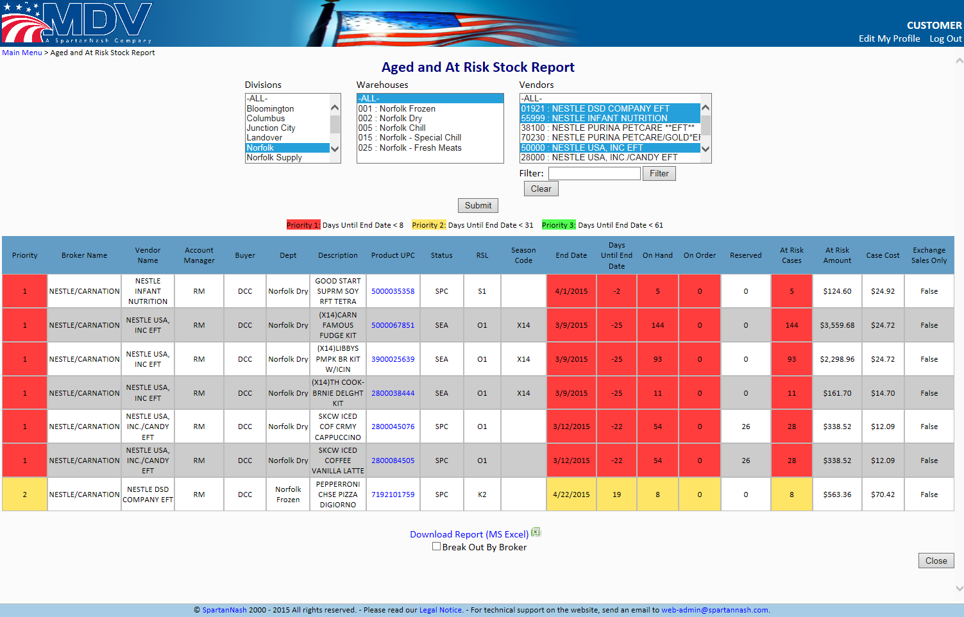

Figure 32 Aged and At Risk Stock Report

The Aged and At Risk Inventory report will show the user information about the products that are deemed to be aged or are at risk of becoming aged. The user can filter by Division, Warehouse and Vendor or display all results in each of those categories. There are multiple conditions that would signify that a product is aged or at risk of becoming aged, among them are:
- The status of a product is not STK, VCT, VLT, or TMP.
- On Hand and the On Order quantity must be greater than 0
- The birth date of the Product is greater than 30 days past.
When the data returns from the database query the data is displayed on screen in a table. Items are color coded based on the severity of the age risk.

The table can also be downloaded to the user’s local computer as a Microsoft Excel (*.xlsx) file.

New Stock Report

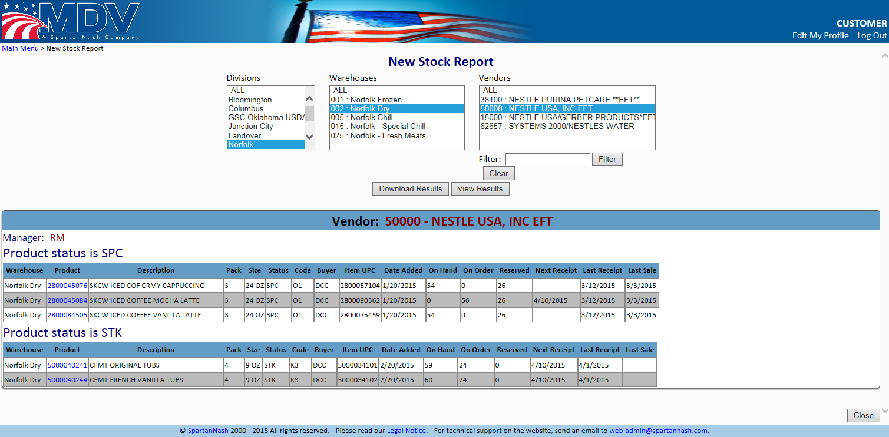
Figure 33 New Stock Report

The New Stock Report provides a report on the items that can be considered new. The data for this report is refreshed every morning. New items are those that are marked with a status of NEW or OTB (One Time Buy) or the Birth Date of the product is less than 60 days previous. This page initially starts with the standard three column selector of division, warehouse, and vendor. Only one selection may be made in each column. The population of the divisions table causes the warehouse list to fill its entries with the warehouses that make up that division. Selecting a warehouse populates the vendor list with only the vendors that have products that were deemed New.
When data is returned it is displayed as a series of tables. Each table shows the products and how they were deemed to be new. There will be a table for products with a status of NEW. There will be a table for products with a status as OTB, and there will be tables for any other products that are less than 60 days old (based on the Date Added column). Each different status will be represented by its own table. The report can be downloaded as a Microsoft Excel file (*.xlsx) that contains the data table information by clicking the ‘Download Results’ button.

Code Date Inquiry

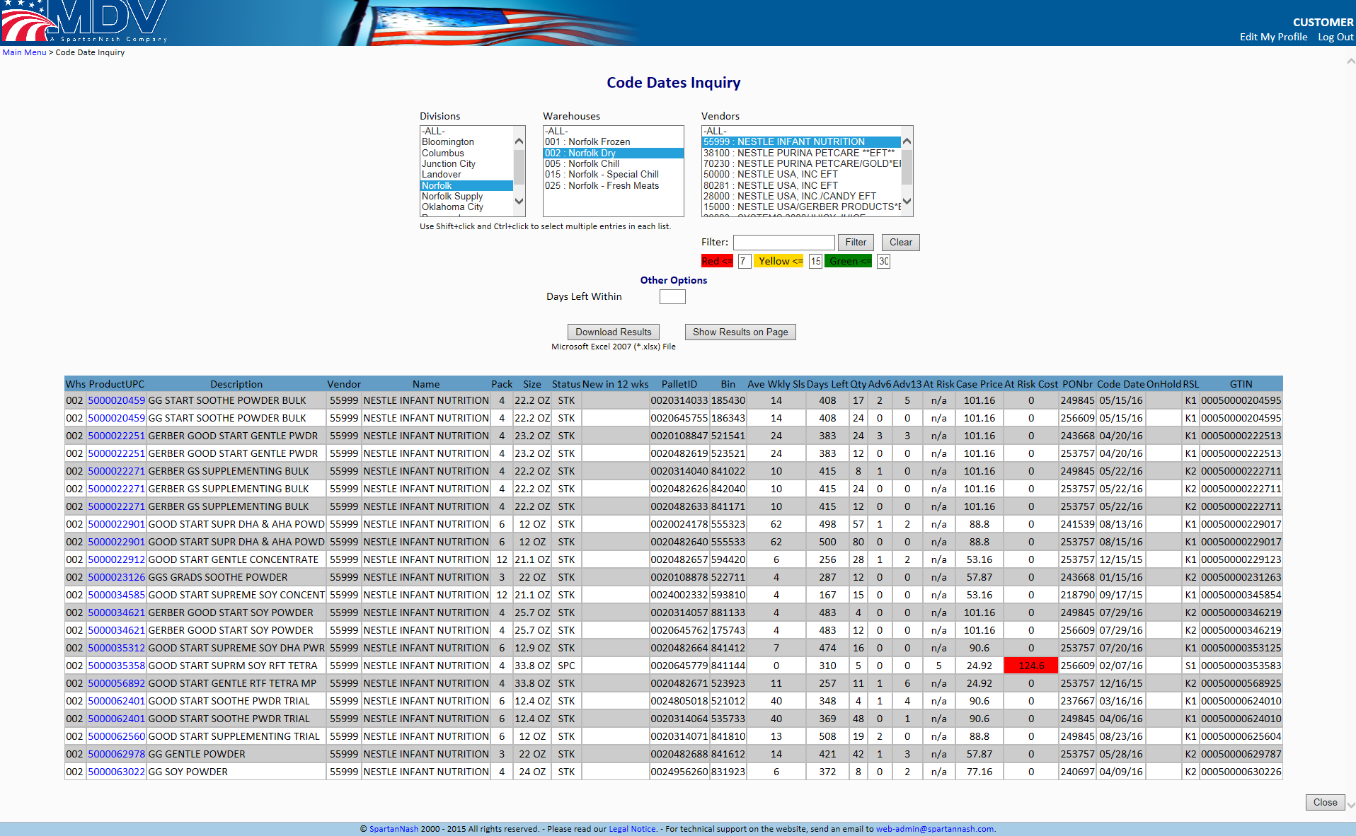
Figure 34 Code Dates Inquiry

This page allows the user to research the items in our divisions that have a code date value that is being tracked. The user can select the division, warehouse and vendor to display by selecting the values from the provided lists. The results of the query can be viewed on the current page or downloaded to a Microsoft Excel spreadsheet (*.xlsx) file by clicking the ‘Download Results’ button.
Items are color-coded based on any risk associated with the Code Date (indicating the number of days left until the Code Date is reached.

Tools

Proof of Delivery Documents Retrieval

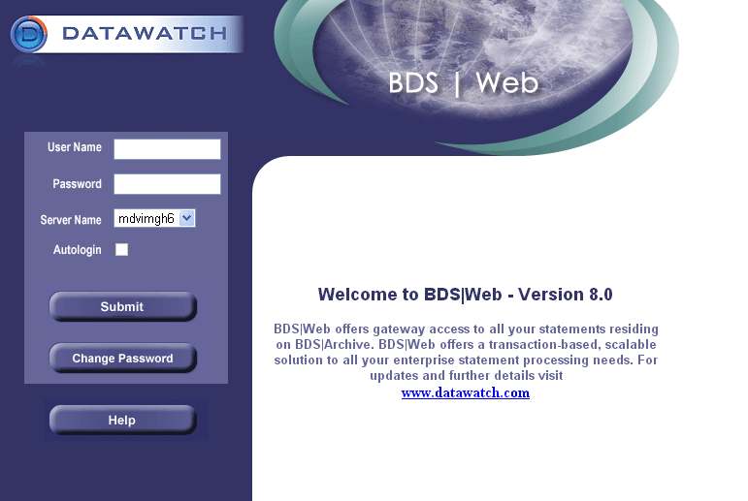
Figure 35 Login page for BDS Web

If a user needs access to the scanned and filed copies of Proof of Delivery (POD) documents that MDV has archived, it can be obtained using this tool. It is a separate feature from the main data services area and requires an extra approval step, but it is still maintained by MDV. Clicking the Proof of Delivery Documents Retrieval link will open a new window for the BDS login page.

To Request Proof of Delivery Doc Access

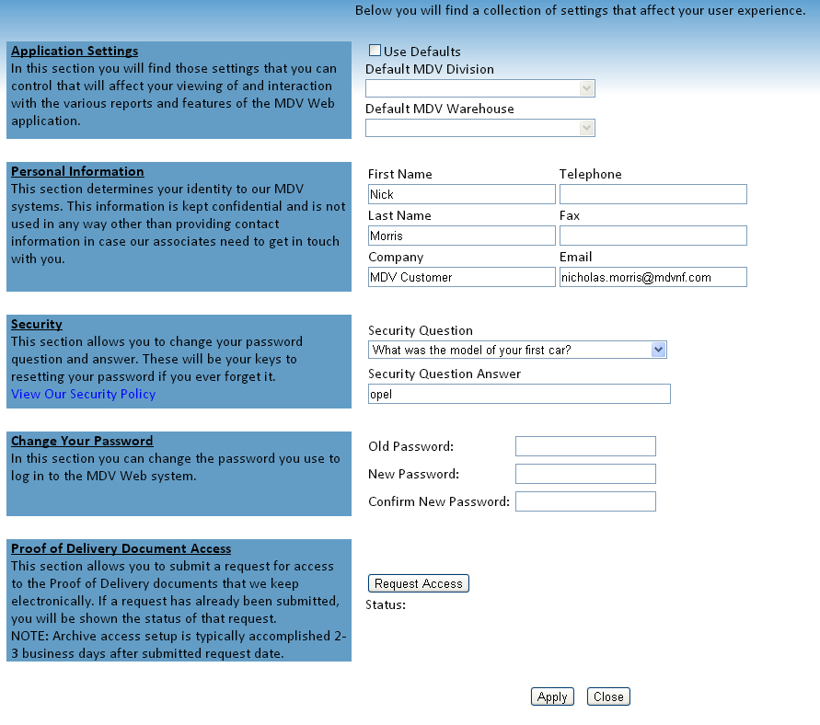
Figure 36 Request Proof of Delivery Doc Access

Clicking on this link will direct the user back to the Edit Profile Page. Here they can make any changes they desire to their profile on the MDV Website. In order to request access to the Proof of Delivery tool, the user simply needs to click the Request access button.

Bulk Reporting

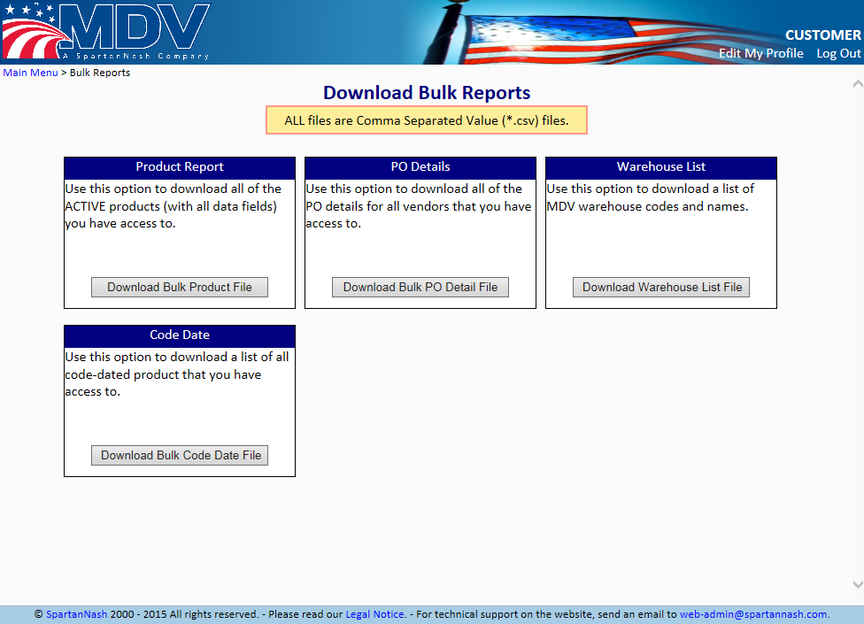
Figure 37 Bulk Download

The Download Bulk Reports page allows users to obtain data files (*.csv – Comma Separated Values) that contain large swaths of the data that they are authorized to view. Four files are made available:
- Product Report – this option contains all of the Active products across all divisions that a customer is authorized to see.
- PO Details – this option contains all of the MDV purchase order details for the products a customer is authorized to see.
- Warehouse List – is a listing of the numeric codes and names of all warehouses for all divisions in the MDV family.
- Code Date – this option contains all of the Code Date details (see 3.14 Code Date Inquiry) across all divisions for all products the customer is authorized to see.

MDV Phone Directory

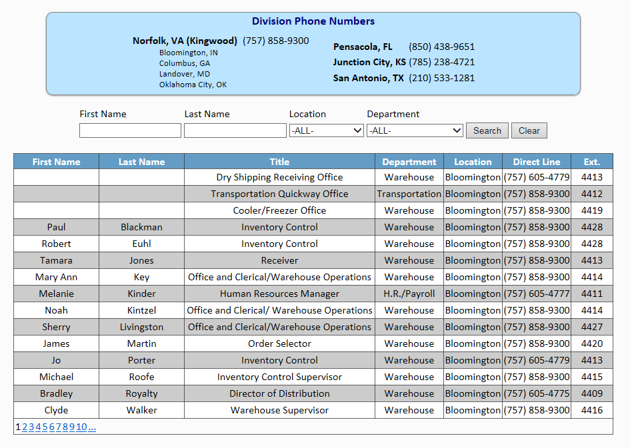
Figure 38 MDV Phone Directory

The Phone Directory page has contact information for MDV employees that can be searched by First and Last Name, Location and Department.

